CSE 3241 Project Checkpoint 02 – Relational Model and Relational Algebra

Names: Defne, Maddison Chaffin, Ceyhan, Yi-Ting Tsan Date: 10/10/2022

In a **NEATLY TYPED** document, provide the following:

1. Provide a current version of your ER Model as per Project Checkpoint 01. If you were instructed to change the model for Project Checkpoint 01, make sure you use the revised version of your ER Model.

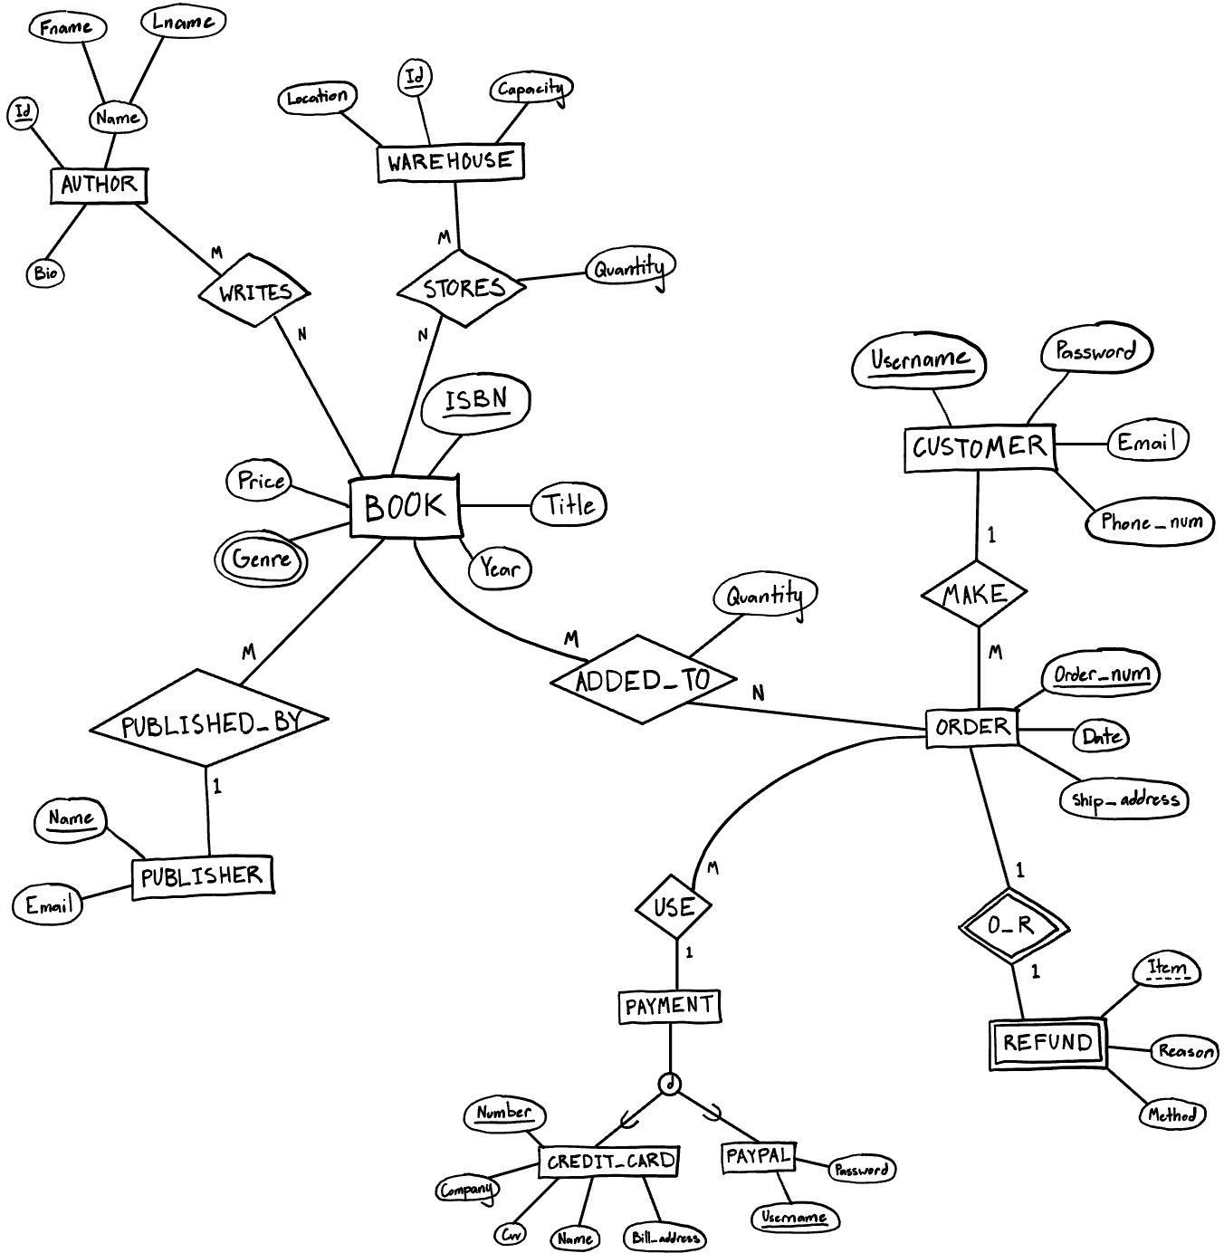

1. Map your ER model to a relational schema. Indicate all primary and foreign keys.
   * BOOK(Isbn, Price, Title, Year, P_name (FK))
   * GENRE (B_isbn (FK), Genre)
   * AUTHOR(Id, Fname, Lname, Bio)
   * WAREHOUSE(Id, Location, Capacity)
   * CUSTOMER(Username, Password, Email, Phone_num)
   * PUBLISHER (Name, Email)
   * ORDER(Order_num, Date, Ship_address, Customer_username(FK), Creditcard_number(FK), Paypal_username(FK))
   * CREDIT_CARD(Number, Company, Cvv, Name, Bill_address)
   * PAYPAL(Username, Password)
   * STORES (B_isbn(FK), W_id(FK), Quantity )
   * WRITES (B_isbn(FK), A_Id(FK))
   * ADDED_TO (B_isbn(FK), O_order_num(FK), Quantity)
   * REFUND(Order_num(FK), Item, Reason, Method)
2. Given your relational schema, provide the relational algebra to perform the following queries. If your schema cannot provide answers to these queries, revise your ER Model and your relational schema to contain the appropriate information for these queries:
3. Find the titles of all books by Pratchett that cost less than $10



1. Give all the titles and their dates of purchase made by a single customer (you choose how to designate the customers)

CustomerSelection← π 𝑈𝑠𝑒𝑟𝑛𝑎𝑚𝑒 (𝐶𝑈𝑆𝑇𝑂𝑀𝐸𝑅 )

OrderSelection ← π 𝑂𝑟𝑑𝑒𝑟𝑁𝑢𝑚, 𝐷𝑎𝑡𝑒 ( σ

𝑂𝑅𝐷𝐸𝑅)

(𝐶𝑢𝑠𝑡𝑜𝑚𝑒𝑟𝑈𝑠𝑒𝑟𝑛𝑎𝑚𝑒 = 𝐶𝑢𝑠𝑡𝑜𝑚𝑒𝑟𝑆𝑒𝑙𝑒𝑐𝑡𝑖𝑜𝑛)

IsbnSelection ← π 𝐵𝑖𝑠𝑏𝑛 , 𝐷𝑎𝑡𝑒( 𝑂𝑟𝑑𝑒𝑟𝑆𝑒𝑙𝑒𝑐𝑡𝑖𝑜𝑛 ⋈

𝐴𝐷𝐷𝐸𝐷𝑇𝑂)

(𝑜𝑟𝑑𝑒𝑟𝑁𝑢𝑚 = 𝑂_𝑜𝑟𝑑𝑒𝑟_𝑛𝑢𝑚)

π 𝑇𝑖𝑡𝑙𝑒, 𝐷𝑎𝑡𝑒 ( 𝐼𝑠𝑏𝑛𝑆𝑒𝑙𝑒𝑐𝑡𝑖𝑜𝑛 ⋈ 𝐵𝑂𝑂𝐾)

(𝐼𝑠𝑏𝑛 = 𝐼𝑠𝑏𝑛𝑆𝑒𝑙𝑒𝑐𝑡𝑖𝑜𝑛)

1. Find the titles and ISBNs for all books with less than 5 copies in stock

IsbnList ← π𝐼𝑆𝐵𝑁(σ(𝑄𝑢𝑎𝑛𝑡𝑖𝑡𝑦<5)𝑠𝑡𝑜𝑟𝑒𝑠)

𝐵𝑜𝑜𝑘

π

𝐼𝑆𝐵𝑁, 𝑇𝑖𝑡𝑙𝑒

(𝐼𝑠𝑏𝑛𝐿𝑖𝑠𝑡 ⋈𝐼𝑆𝐵𝑁 = 𝐼𝑠𝑏𝑛 )

1. Give all the customers who purchased a book by Pratchett and the titles of Pratchett books they purchased

π 𝐶𝑈𝑆𝑇𝑂𝑀𝐸𝑅⋈ (𝑂𝑅𝐷𝐸𝑅⋈ (𝐴𝐷𝐷𝐸𝐷 𝑇𝑂⋈ (𝐵𝑂𝑂𝐾⋈

𝑈𝑠𝑒𝑟𝑛𝑎𝑚𝑒, 𝑇𝑖𝑡𝑙𝑒 𝑈𝑠𝑒𝑟𝑛𝑎𝑚𝑒=𝐶𝑢𝑠𝑡𝑜𝑚𝑒𝑟 𝑢𝑠𝑒𝑟𝑛𝑎𝑚𝑒 𝑂𝑟𝑑𝑒𝑟 𝑛𝑢𝑚=𝑂 𝑜𝑟𝑑𝑒𝑟 𝑛𝑢𝑚 𝐵 𝐼𝑠𝑏𝑛=𝐵 𝐼𝑠𝑏𝑛 𝐼𝑠𝑏𝑛=𝐵 𝐼𝑠𝑏𝑛

(𝑊𝑅𝐼𝑇𝐸𝑆⋈ (σ (𝐴𝑈𝑇𝐻𝑂𝑅))))))

𝐴 𝐼𝑑 = 𝐼𝑑 𝐿𝑛𝑎𝑚𝑒 = '𝑃𝑟𝑎𝑡𝑐ℎ𝑒𝑡𝑡'

1. Find the total number of books purchased by a single customer (you choose how to designate the customer)





TotalBooksPurchased1← 

1. Find the customer who has purchased the most books and the total number of books they have purchased

***Based on problem e***

𝑇𝑜𝑡𝑎𝑙𝐵𝑜𝑜𝑘𝑠 ← π 𝑇𝑜𝑡𝑎𝑙𝐵𝑜𝑜𝑘𝑠𝑃𝑢𝑟𝑐ℎ𝑎𝑠𝑒𝑑1, 𝑇𝑜𝑡𝑎𝑙𝐵𝑜𝑜𝑘𝑠𝑃𝑢𝑟𝑐ℎ𝑎𝑠𝑒𝑑2, ... 𝑇𝑜𝑡𝑎𝑙𝐵𝑜𝑜𝑘𝑠𝑃𝑢𝑟𝑐ℎ𝑎𝑠𝑒𝑑𝑁(𝐶𝑢𝑠𝑡𝑜𝑚𝑒𝑟) π 𝑈𝑠𝑒𝑟𝑛𝑎𝑚𝑒(𝐹 𝑀𝐴𝑋 𝑞𝑢𝑎𝑛𝑡𝑖𝑡𝑦 (𝑇𝑜𝑡𝑎𝑙𝐵𝑜𝑜𝑘𝑠))

1. Come up with three additional interesting queries that your database can provide. Give what the queries are supposed to retrieve in plain English and then as relational algebra. Your queries should include joins and at least one should include an aggregate function. At least one of your queries should use “extra” entities you added to your model in Checkpoint 01.

* Retrieve the customer username who use paypal for payment(Assume Paypal usernames are same as Customers’ usernames)
  + π 𝐶𝑢𝑠𝑡𝑜𝑚𝑒𝑟

(𝑃𝑎𝑦𝑝𝑎𝑙⋈ 𝑢𝑠𝑒𝑟𝑛𝑎𝑚𝑒 = 𝑢𝑠𝑒𝑟𝑛𝑎𝑚𝑒 )

𝑢𝑠𝑒𝑟𝑛𝑎𝑚𝑒

* Find the warehouse with the greatest quantity of a certain book (specified by ISBN=

712 − 2 − 89 − 648514 − 4):

* + 𝐹𝐼𝑑, 𝑀𝐴𝑋 𝑄𝑢𝑎𝑛𝑡𝑖𝑡𝑦(𝑊𝐴𝑅𝐸𝐻𝑂𝑈𝑆𝐸⋈𝐼𝑑=𝑊 𝑖𝑑(σ𝐵 𝐼𝑠𝑏𝑛 = 712−2−89−648514−4(𝑆𝑇𝑂𝑅𝐸𝑆)))
* Find all the items to refunded on orders from a specific date (10-27-2002):
  + π𝐼𝑡𝑒𝑚(𝑅𝐸𝐹𝑈𝑁𝐷⋈𝑂𝑟𝑑𝑒𝑟 𝑛𝑢𝑚 = 𝑂𝑟𝑑𝑒𝑟 𝑛𝑢𝑚(σ𝐷𝑎𝑡𝑒='10−27−2002'(𝑂𝑅𝐷𝐸𝑅)))

**See Section 1 Page 2 for the new relational schema**

**See Section 2 Page 4-7 for the new relational algebra for above queries**